[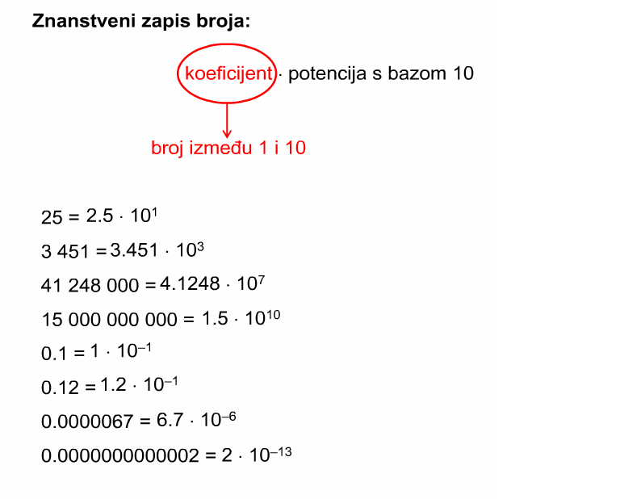](http://ivana-sovagovic.is-a-teacher.com/wp-content/uploads/2014/05/znanstveni-zapis-broja.png)